CS 255 System Design Document

UML Diagrams

UML Use Case Diagram
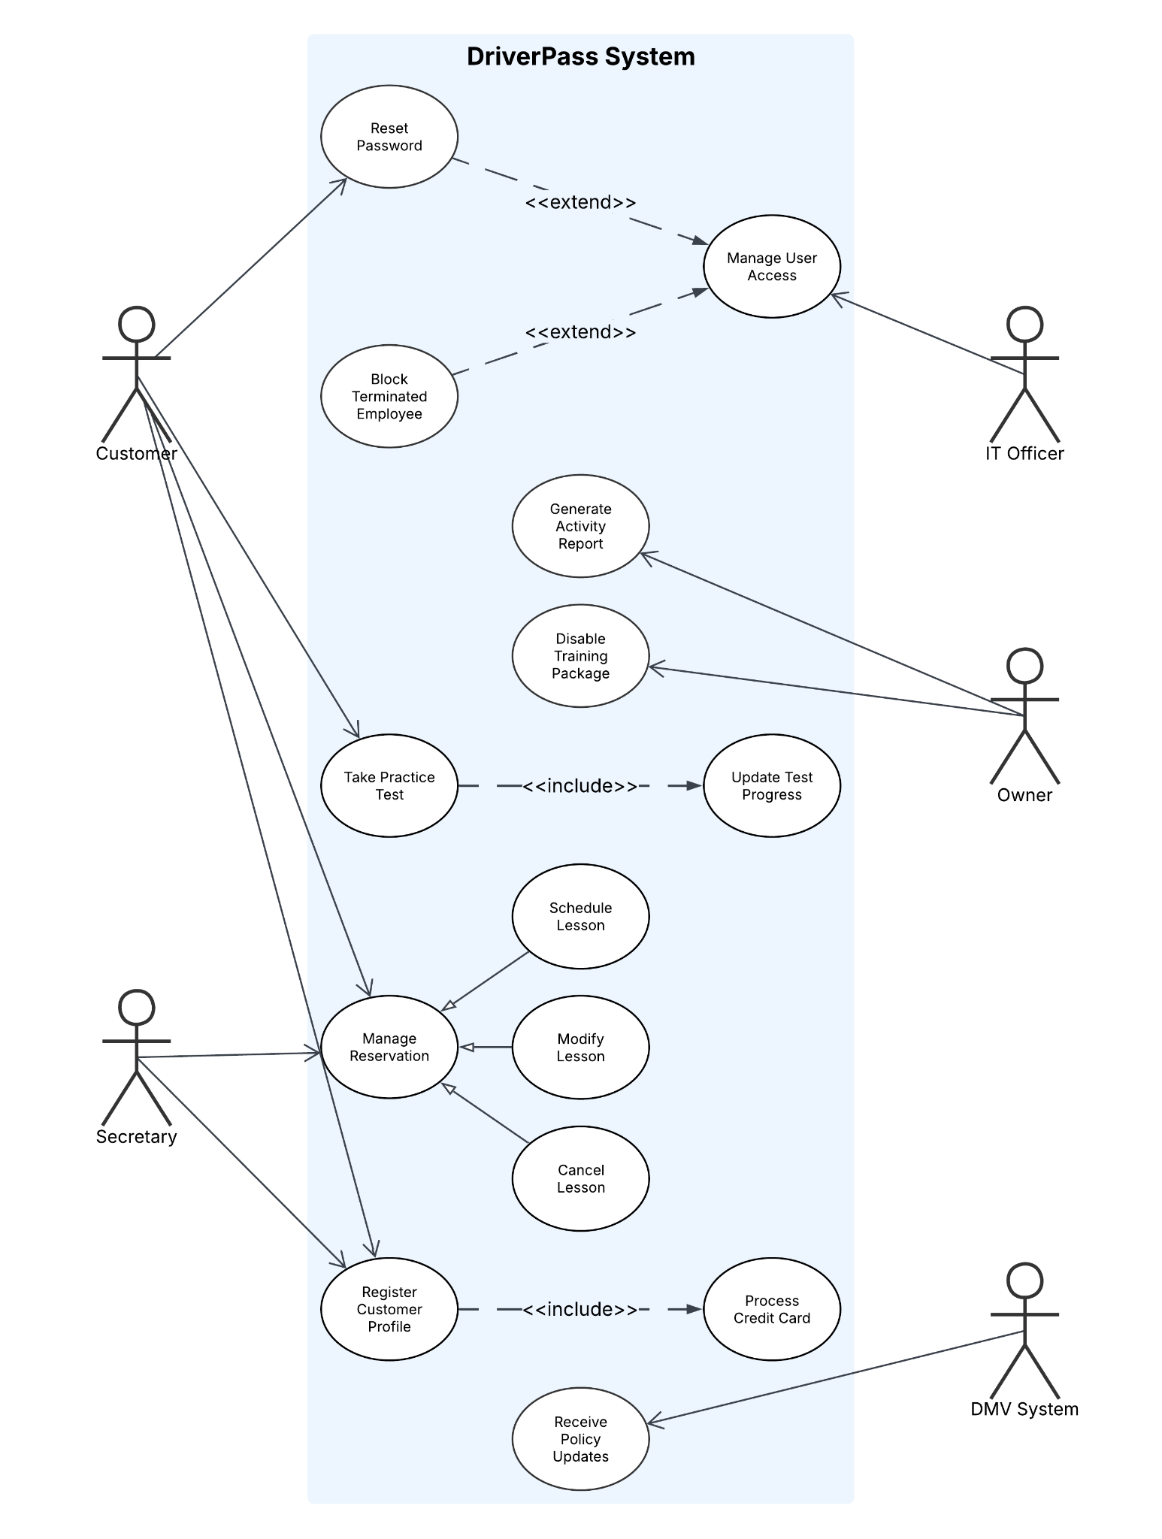

UML Activity Diagrams
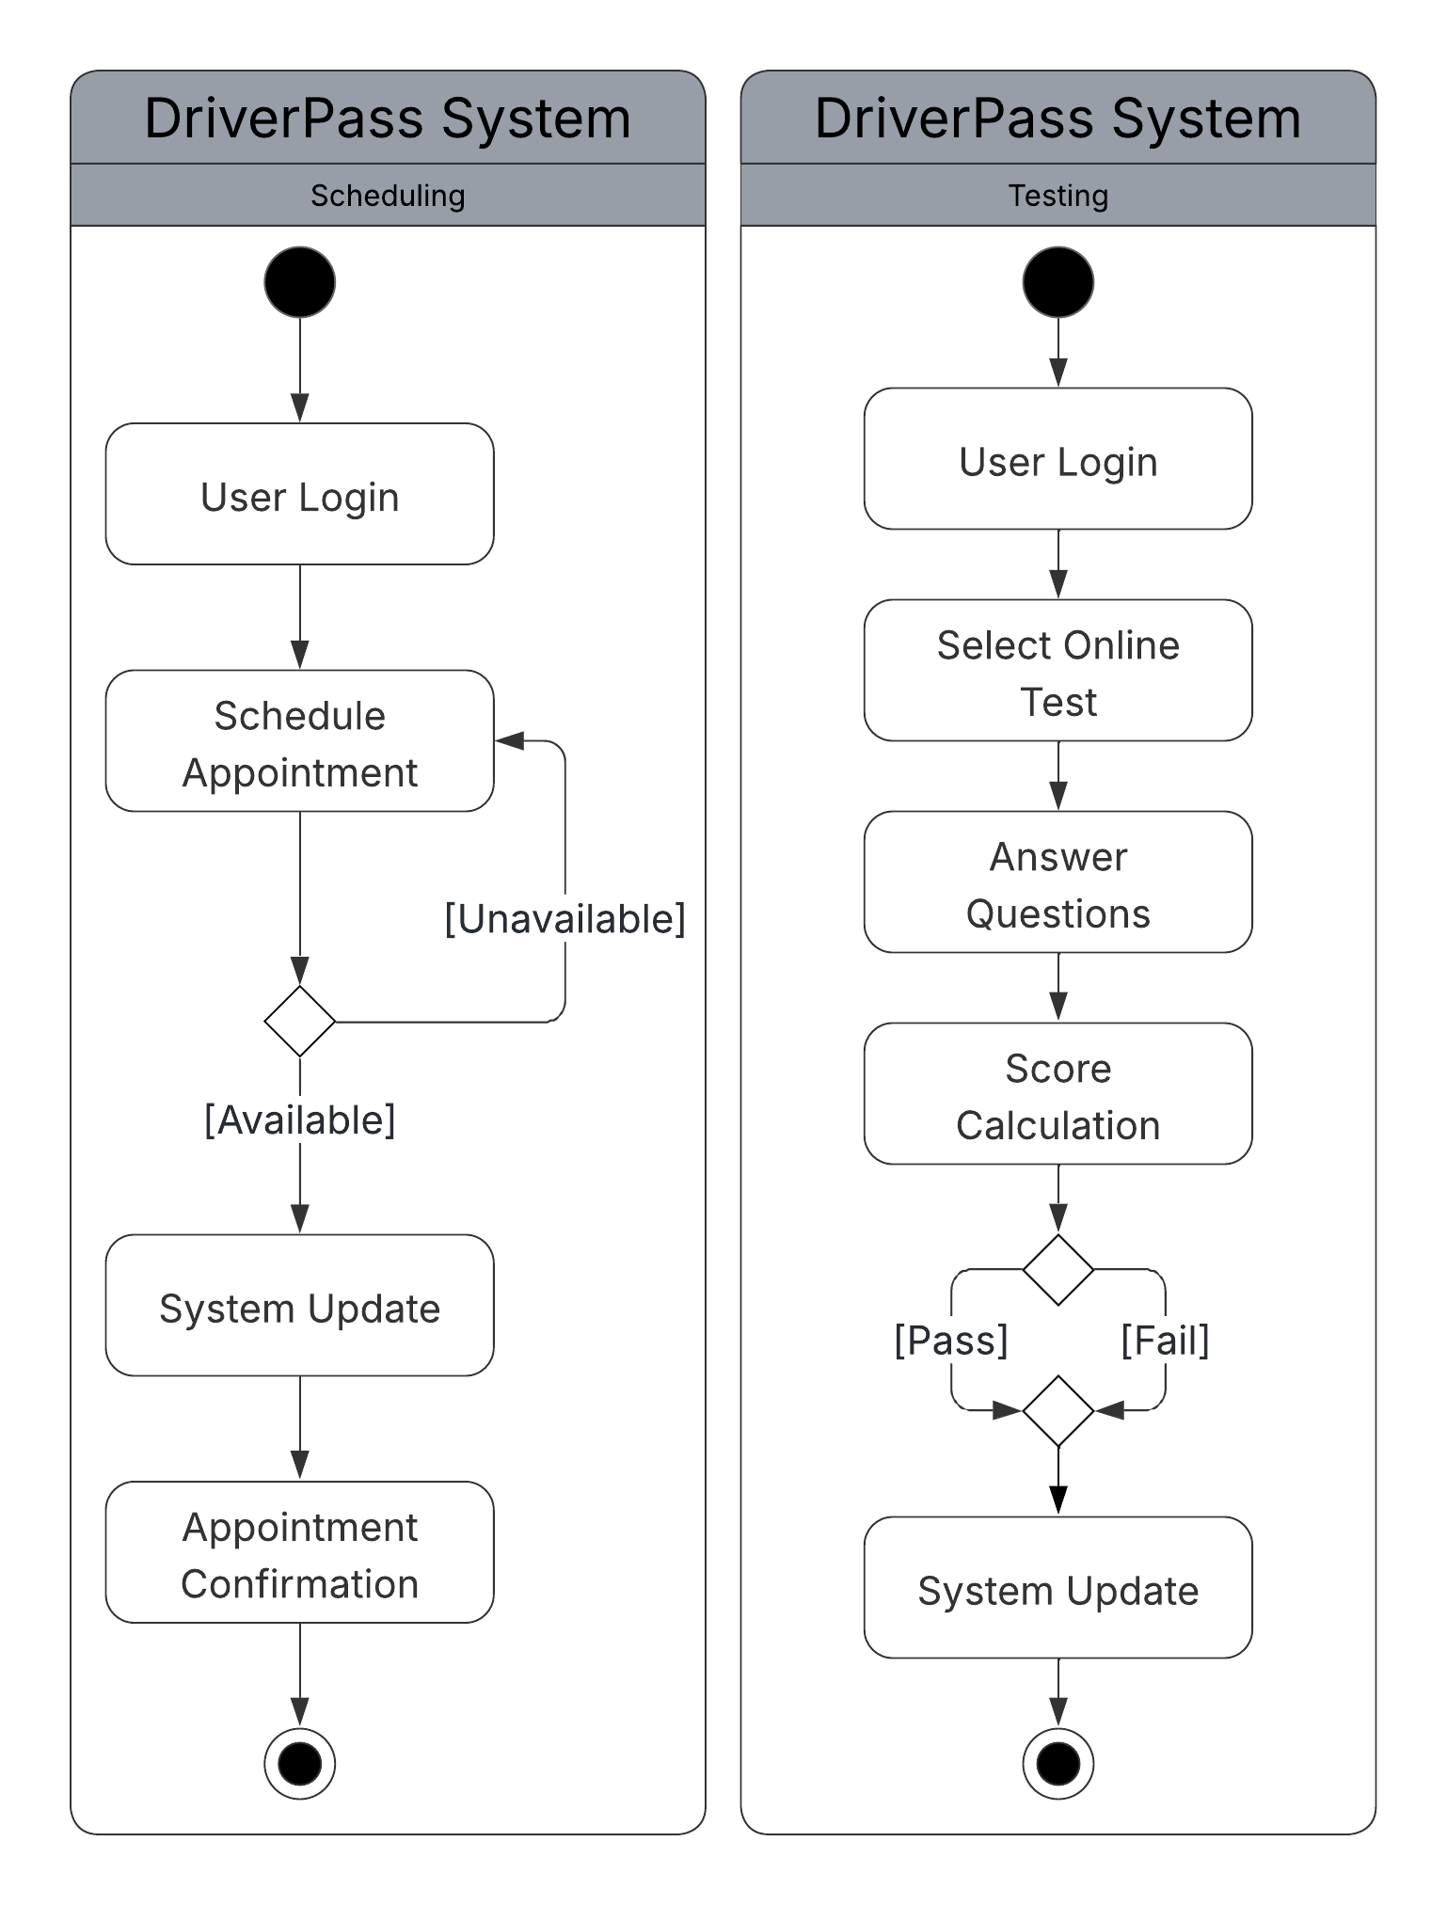

UML Sequence Diagram
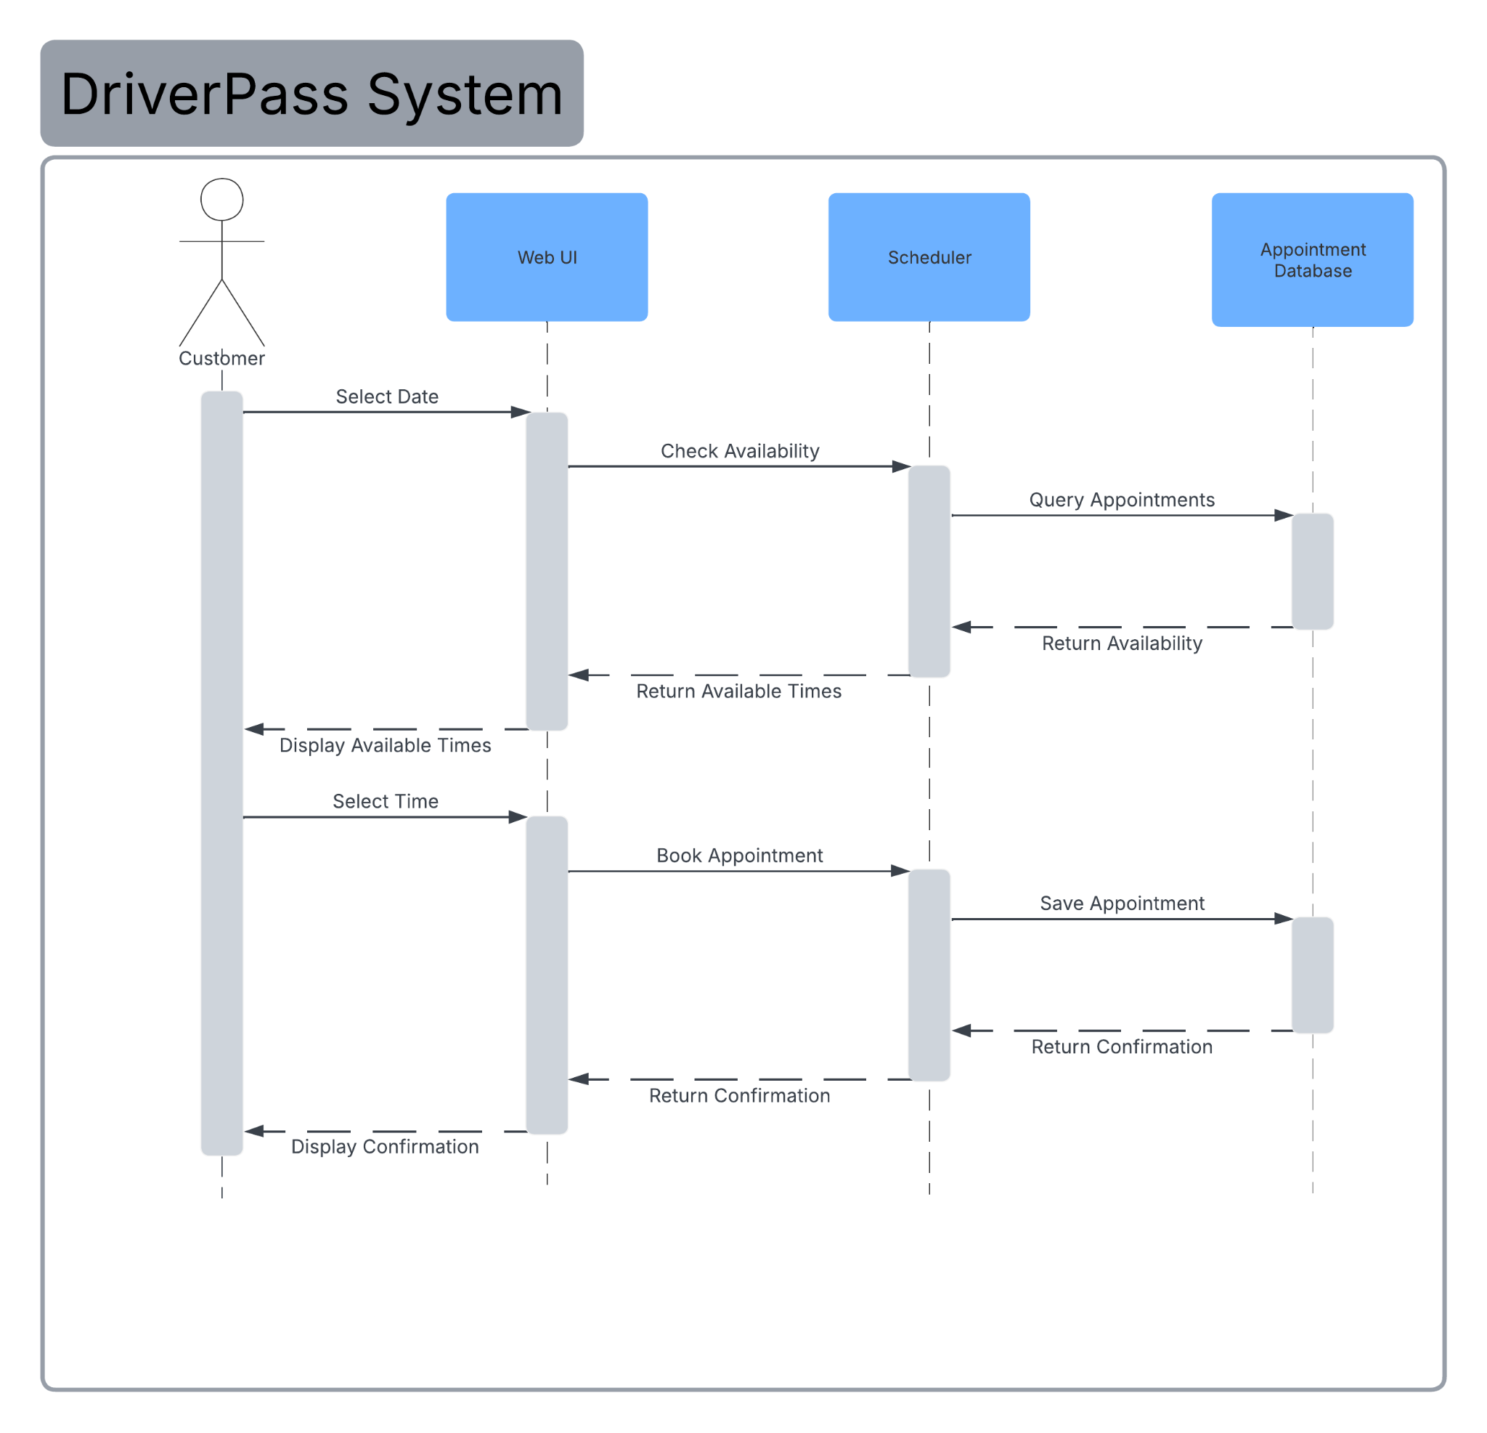

UML Class Diagram
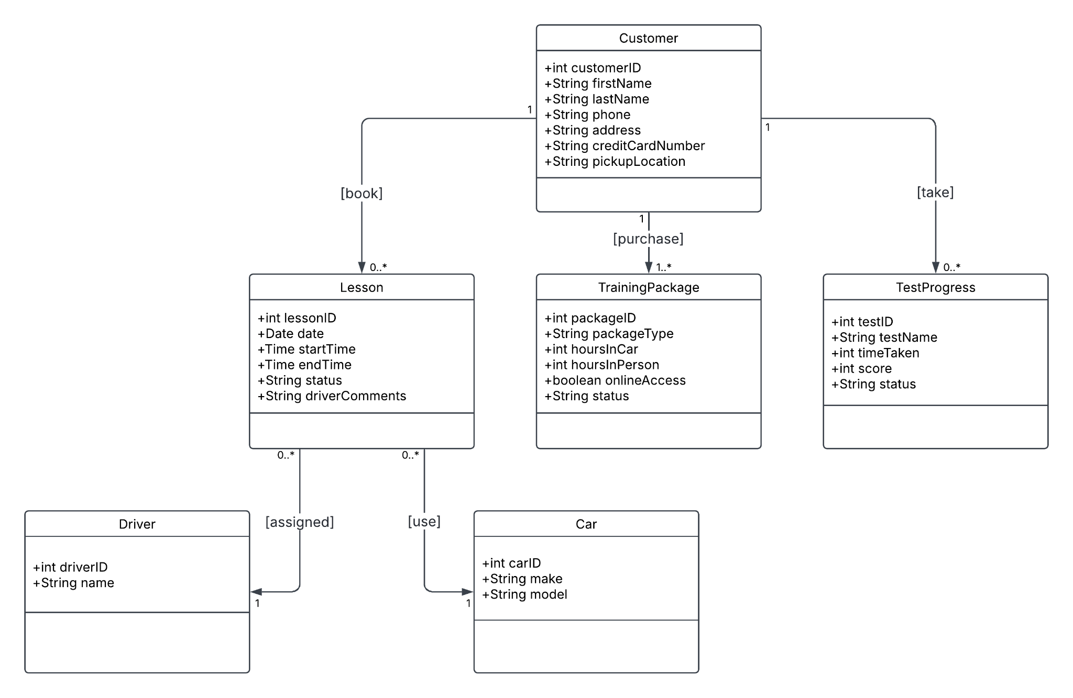

Technical Requirements
- Hardware and Infrastructure:
By hosting the system in the cloud, we eliminate the need for the business to buy or maintain any local computer servers. The only hardware required for the staff and students are standard, internet-connected devices like PCs, laptops, or tablets. The cloud environment also automatically handles backups and ensures the system is always available.
- Software:
The system relies on a solid backend database to track customer information, process live schedule updates, and manage the ten different cars and drivers without creating duplicate records. It also needs to implement Role-Based Access Control (RBAC) to keep administrative features securely separated from the student-facing tools.
- Security:
To keep everything safe, the system must use standard encryption to secure the connection and protect sensitive customer payment details from being intercepted during transactions.
- External Tools:
While the system handles the daily operations online, it must also be able to generate downloadable activity reports. This allows the owner to pull their data and work offline using familiar tools like Microsoft Excel.

